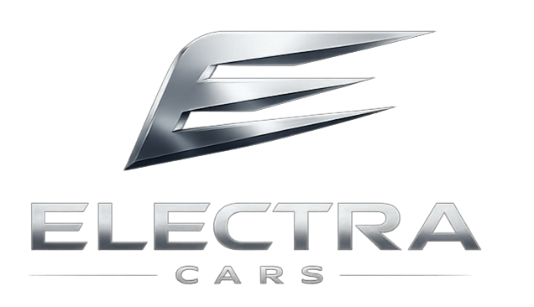  BOOK TEST DRIVE AGENT  Agentforce Hackathon 2026 | Abstract  The solution presented by Team ThinkForge to showcase how Agentforce can help to solve one of the key problems of Automotive Industry to enhance the test drive booking experience making it hassle free and smooth experience for prospective customers as well as to the company/dealerships to capture smooth data capture through an Agentic experience.

Contents
The Industry Problem (Automotive Cloud) 3
Objective/Mission 3
Leveraged tools and technologies 3
Simplified Experience Flow 4
Features and functionality 5
Automotive Cloud 5
Salesforce CMS 5
Experience Cloud 5
Agentforce 5
Salesforce Personalization 5
Salesforce personalization powers two live nudges: 6
Flows 6
Apex classes 6
Twilio integration (API) 8
Slack integration 8
Data Cloud 9
External websites being leveraged 9
Webhook url 9
Weather API 9
Potential improvements 10

TEAM THINKFORGE

Presented by:
- Prithi Ranjan Mitra
- Shashank Kumar
- Arpita Bannerjee
- Saswata Mukherjee
- Jisnu P S
Company: Accenture

The Industry Problem (Automotive Cloud)
Electra Cars, an original equipment manufacturer (OEM), features a premium website showcasing its latest vehicle models. Currently, customers who want a test drive must fill out a lengthy manual form or request a callback.

Current Pain Points
- High Friction: The form is too long, leading to a massive drop-off rate.
- Low Conversion: Only 1% of website visitors book a test drive.
- Manual Bottlenecks: Call center teams spend too much time chasing customers for missing information, such as model, location, and time.

Objective/Mission
Automate the test drive booking journey. Replace the "clunky form" culture with a seamless, AI-driven experience using Agentforce to maximize conversions and data accuracy.

Leveraged tools and technologies
- Automotive Cloud
- Salesforce CMS
- Experience Cloud
- Agentforce
- Salesforce Personalization
- Flows
- Custom components like LWC and Apex classes.
- Twilio integration – For WhatsApp communications with customers.
- Slack integration – For dealers to receive notifications and make any changes to the test drive appointments.
- Additional web urls
- Open APIs

Simplified Experience Flow


Agentforce helps with the conversation
Customer visits the website
Agentforce is smart enough to know Vehicle model and location. In case location is somehow not available, it will ask for those details
Browse and selects a car. If he/she turns away, will be prompted to “book a test drive”
Agentforce guides the conversation to choose models, capture details like FirstName, LastName. Based on the location automatically shows the nearest dealer with distance. Presents with available slots to choose. Shows the weather forecast for the chosen day.
Everything under 2 mins.

Booking conversation
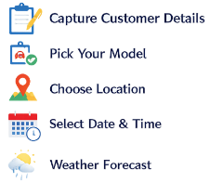
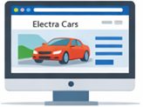

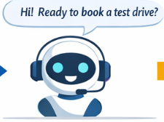

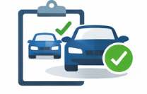
Test drive booking confirmation
Agentforce is sends the confirmation details on WhatsApp to customer and a Slack notification to the dealer





Features and functionality

Automotive Cloud
Leveraged core data models like Leads, Vehicles, Service territories, Service Appointments, Test Drive Booking. The vehicle model names are also stored in Asset object.

Salesforce CMS
To host assets related to the Electra Cars consumer-facing website. CMS workspace, CMS channels etc.

Experience Cloud
To host the Electra Cars consumer facing website with different pages like HomePage, Vehicle-Detail page, Concierge-page (to allow conversational test drive booking through Agentforce)

Agentforce
- To power the autonomous agent actions and reasoning
  - to handle seamless data capture and smoothen customer’s experience without presenting any forms.
  - Guides the customers to select available vehicle models, capture their details and contact information, shows the nearest available dealer (up to 50 Kms), helps to book slots with ease, provides the weather forecast for the selected day and books the test drive.
  - Send notifications to the customer on WhatsApp.
  - Customers may cancel the appointment, and status is automatically reflected in the appointment record.
  - To help dealers in receiving notification for test drives getting booked in their respective service territories.

Salesforce Personalization
Salesforce Personalization is used to proactively engage website visitors at two key moments in their journey. As customers browse the Electra Cars website, their behavior across pages is continuously captured by what they are viewing, which vehicles they are exploring and how they are navigating giving the system real-time context about their intent.

Salesforce personalization powers two live nudges:
The first is a 30-second nudge bottom-left slide-in card that invites the customer to book a test drive with the Electra AI Agent before they have even thought about leaving.
The second is an exit intent overlay triggered when the customer is about to navigate away from the website. A full-screen card appears with the message "Wait — before you go!", highlighting that the AI can match with the perfect Electra model and book a test drive at their nearest dealership in under 2 minutes, with a direct Chat with Electra CTA.
In future, this behavioral data can be tied to a unified customer profile post-purchase to deliver a deeply personalized experience across the entire ownership journey.

Flows
FLOW NAME | PURPOSE
Route to ElectraCars Agent from Exp Cloud | Routes the messaging session from Experience Cloud hosted agentic window to the Agent
Get_Vehicle_Names_and_store | Find the vehicle names from Asset and store it in a variable.
Test_Drive_Appointment_Details | Captures customers’ details and creates a lead record
Service_Appointment_Creation | Creates a service appointment record based on customer’s choice of dealer and time slot
Update_ServiceAppointment_Status | Update the service appointment status from dealer side in case of any kind of cancellation
Create Test Drive Record
Booking Confirmation to Dealership | Sends Test drive confirmation notification to the Dealer’s channel
Booking Cancellation to Dealership | Sends Test drive cancellation notification to the Dealer’s channel

Apex classes
APEX CLASS NAME | PURPOSE
ElectraCmsController | It serves as the data bridge between Salesforce CMS and the LWC components, specifically fetching rich vehicle details and public image URLs using their unique Content Keys.
Electra_VehicleOptions | It serves as an Apex data provider that retrieves the list of available car models and their metadata to populate the selectable options (chips/buttons) within the Agentforce conversation.
ElectraAgentBridge | It acts as the secure intermediary that passes user messages and grounding context (like Location and Vehicle ID) to the Agentforce engine, while parsing the AI's raw responses into a format your custom LWC can render.  It essentially translates "human chat" into "AI instructions" and back again to keep the booking conversation flowing.
AF_TerritoryRoutingInvocable | It finds the nearest dealership Service Territories for a customer by first using their GPS coordinates from the website and falling back to the Lead's geocoded postal address if coordinates are unavailable. It expands the search radius progressively from 5 km up to 50 km until it finds results, then returns the top 3 closest dealerships with their IDs, names, and distances for Agentforce to present as options to the customer.
AF_GetDealerSlotsInvocable | It retrieves available test drive time slots for a given dealership territory and work type. It works by querying Operating Hours, existing ServiceAppointments, and Resource Absences directly via SOQL - deliberately avoiding the LxScheduler API since the Einstein Agent Service user cannot hold a Salesforce Scheduler license.
AF_WeatherInvocable | It fetches the weather forecast for a dealership territory on a given test drive date using the Open-Meteo API, and returns a conversational summary with temperature, conditions, and rain probability for the Agentforce agent to share with the customer.
TwilioInboundWebhook | It is a REST endpoint that receives inbound WhatsApp messages from Twilio and handles customer self-service actions — cancelling or rescheduling a test drive booking by verifying their phone number against the ServiceAppointment before performing any DML. It routes keyword-based replies (e.g. "CANCEL", "RESCHEDULE", "Yes/No") to the appropriate handler and sends conversational WhatsApp responses back via TwilioWhatsAppService.
TwilioWhatsAppService | It is a reusable service class that sends WhatsApp messages to customers via the Twilio Content Template API, handling phone number normalization to E.164 format and supporting both synchronous calls (from Agentforce or the inbound webhook) and asynchronous “future methods” (when a DML operation precedes the callout). It serves as a single outbound messaging layer for booking confirmations, cancellation replies, and reschedule notifications across the entire Electra Cars platform.
AF_FindDealersByRadius | Not applied to the agent for the time being. This Apex would escalate the location-based search for nearest dealer if the user’s location is beyond 50kms.

Twilio integration (API)
For WhatsApp communications with customers.
Item | Details
External Credentials | Twilio_Auth  Auth protocol: Basic Authentication
Principals | TwilioPrincipal  username: AC82350270c3642a63bda44fe178685c99
Names Credentials | Twilio_WhatsApp  url: https://api.twilio.com

Slack integration
For dealers to receive notifications and make any changes to the test drive appointments.
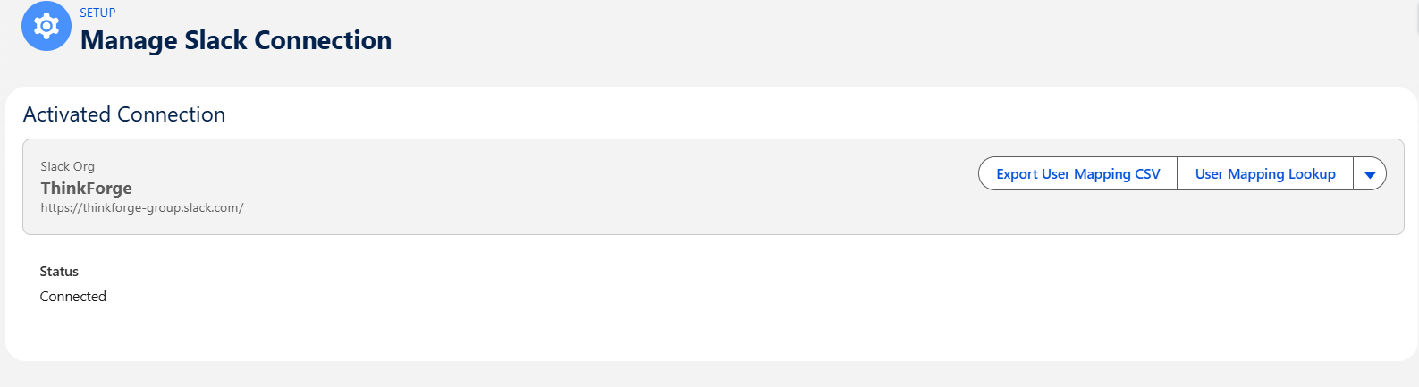
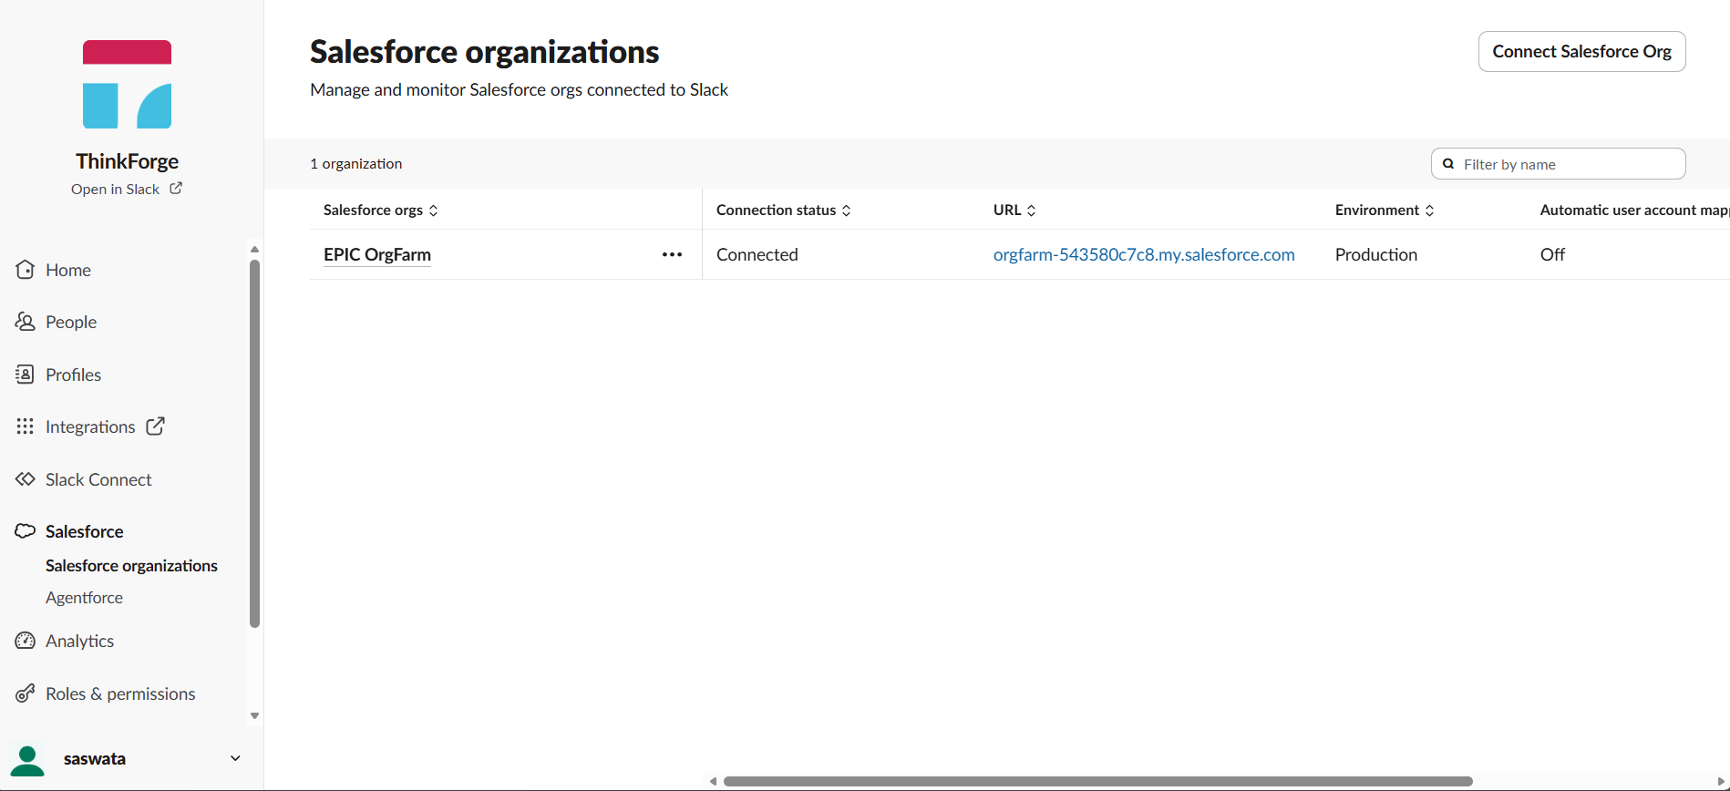

Data Cloud
Data Cloud is used for website data ingestion and customer profile unification. The Electra Cars Experience Cloud website is connected to Data Cloud via the Websites & Mobile Apps connector, which sets up two data streams, one capturing behavioral events (page views, clicks, interactions) and one capturing identity signals from website visitors.
These streams are mapped to the Data Cloud standard data model behavioral events map to Website Engagement and Privacy Consent Log, while identity signals map to the Individual profile object. This builds a unified, consent-aware customer profile from the moment someone visits the website even before they identify themselves.

External websites being leveraged
Personalization url: https://cdn.c360a.salesforce.com
Preview logo custom: https://images.unsplash.com
IP sensing: https://ipapi.co/json/
Reverse geo coding: https://nominatim.openstreetmap.org/reverse

Webhook url
This is used by Twilio for sending the details back to Salesforce in the back end. This gets used when user cancels the appointment from WhatsApp. That automatically triggers the appointment status to be cancelled in ‘Service Appointment’ and ‘Test Drive’ record.
https://orgfarm-543580c7c8.my.salesforce-sites.com/twiliowebhook/services/apexrest/twilio/inbound

Weather API
This is being used to check the weather forecast on the selected day for test drive. This would give an indication to the customer if the weather if in favorable conditions or not.
https://api.open-meteo.com/v1/forecast

Potential improvements
- Leveraging Agentforce Voice for booking test drives with a natural phonic conversation.
- WhatsApp channel alignment directly from salesforce (without depending on other applications such as Twilio)
- Creating an Electra Cars WhatsApp business channel which will be tied to the Agentforce so that existing customers can leverage whatsapp channel to request for any kind of services.
- Implementing a login feature for customers so that they have their own profile including cart etc.
- Implementing a “build your own car” experience and put it on cart. This can be a potential use case for triggering notifications for Abandoned cart through personalization.
- When a lead is converted to a client (“contact”), the unified profile can be tied to the web behaviors captured for that lead.
- Improvements to the Dealership service agent to handle all sorts of booking management capabilities including onboarding/offboarding of staff.
- Leveraging the full-fledged automotive cloud core data model.

